How to Create Application in Java
______________________________________________________________________________
If we want to create application in java we have some important steps.
1. Install JDK
Q. What is JDK?
______________________________________________________________________________
JDK stands for Java Development kit
Def: JDK is a software cluster, or it is group of software it contains multiple inbuilt application or software which provide environment to us to develop and execute java application.
Example: JDK contain compiler, JVM, appletviewer, rmiregistry etc.

Q. what is compiler?
______________________________________________________________________________
Compiler is software or application which present in JDK in terms of java, and which is used for convert your source code to byte code

Q. What is byte code?
______________________________________________________________________________
Byte code machine understandable code or byte code is intermediate code which easily convert in machine code with the help of JVM

Q. what is JVM?
JVM stands for java virtual machine
Def: JVM is also application present in JDK or JRE which is responsible for convert byte code into machine code or which is responsible for load the byte code allocate memory for application as well as allocate memory objects are at run time as well as manage threads and release the memory of object at run time.

Q. Why JAVA develop the byte code? ______________________________________________________________________________
Byte code is platform independent code means java byte code can execute on any operating system without taking any third party support

How to Install JDK
Note: if you want to download the JDK we have to use following link:
Java Downloads | Oracle India
______________________________________________________________________________

2. Create Sample Application
_____________________________________________________
If we want to create any program in java we have some generalize format
Syntax:
access specifier class classname
{ public static void main(String x[])
{ write here your logics
}
}
Example:
public class JulyFirst{
public static void main(String x[])
{ System.out.println(“good morning”);
}
}
Code description
public class JulyFirst
______________________________________________________________________________
Q. what is public?
public is access specifier
Q. what is access specifier?
Access specifier are the some keywords which help us to apply restrictions on class and its member.

There are four types of access specifier in JAVA:
a) public: public access specifier means member can access anywhere in application means within same package as well as outside of package.

b) private: private access specifier means member cannot access outside of class.

c) protected: protected access specifier means member can access only within child class.

d) default: default access specifier means member can access outside of class but within same package cannot access outside of package.

class JulyFirst:
Here class is keyword which is used for declare the class and JulyFirst is classname and user can give any name to his class.

public static void main(String x[]): It is main function of java same like as main function in C or C++
System.out.println(“good morning”): it is output statement of java same like as printf() in c language

Technical meaning:
System is class out is static reference of PrintStream class and System and PrintStream maintain HAS-A relationship between them and println() is overloaded method used for display output on output screen or console window.
Note: we will discuss this meaning in inheritance chapter.

Note: If we want to write code in java we can use editors or tools
Editor: notepad, notepad++ ,sublime text, wordpad
Tools: eclipse,spring tool suite, intelliJ , visual studio etc

3. Save Application
If we want to save java code then you can save in bin folder where JDK install and give class name and file name same with .java extension.

4. Compile Application
Q. what is compilation?
Compilation is process where we can convert source code to byte code in java.
How to compile java program?
______________________________________________________________________________
If we want to compile java program then use the following steps.
a) open command prompt
start menu ---- search ---- command prompt
b) go where java file save
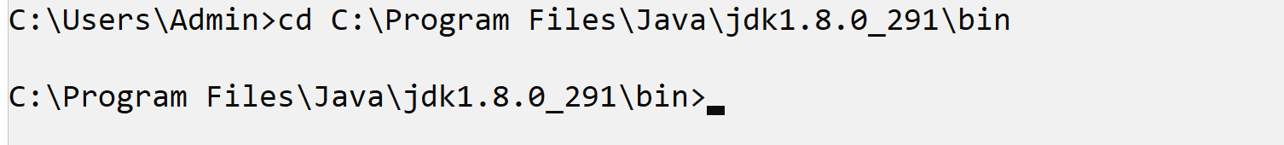
c) type the command javac filename.java
Syntax: javac filename.java
Example: javac JulyFirst.java
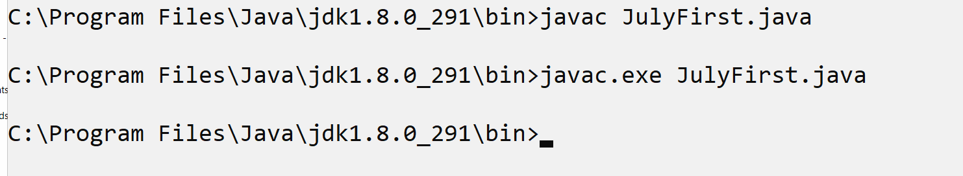
Note: when your program compile successfully then java compiler create new file with extension of .class and in this file contain your byte code.
After compilation we have two files
JulyFirst.java –source code
JulyFirst.class – byte code

5. Run Application: if we want to run java program then we have to use following command
java filename
Example: java JulyFirst

Data Types in JAVA
______________________________________________________________________________
Q. What is data type?
______________________________________________________________________________
Data type means to decide what kind of information or data we want to use in code called as data type.

There are two types of data type in JAVA.
1. Primitive data type: primitive data type means those data type does not store address of memory just able to store simple value in it called as primitive data type.
2. Referential data type: those data type can store address of memory called as referential data type.
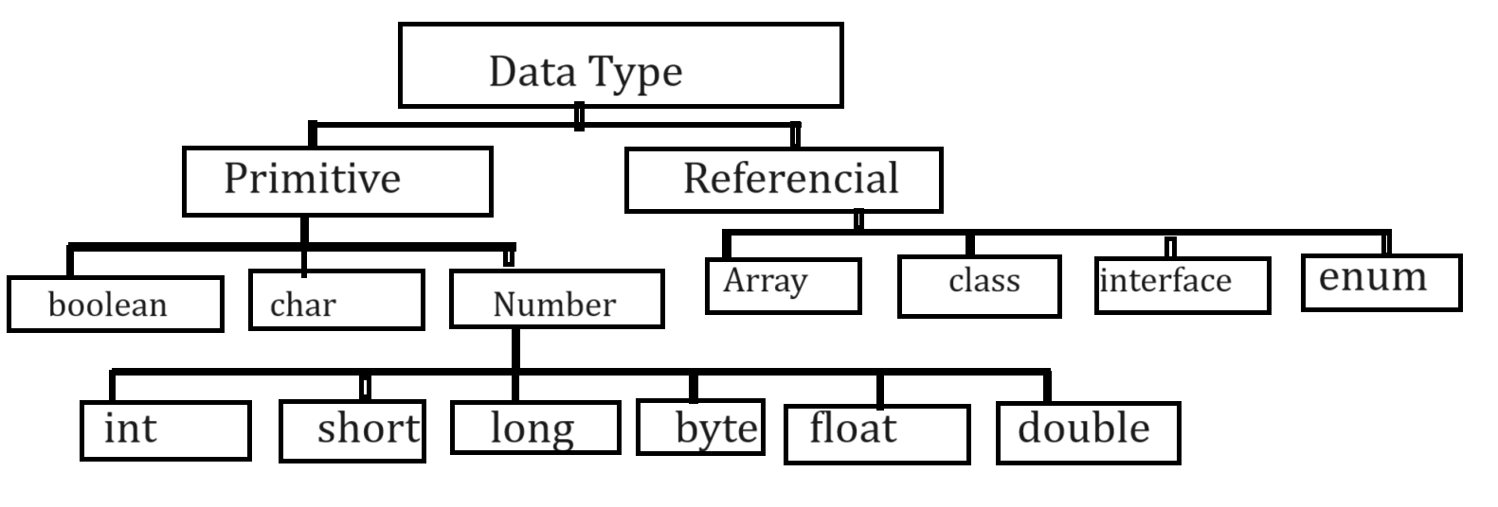
Now we want to discuss about the primitive data type.
1. Integer: the major purpose of integer data type is store non floating values.
Example: 100, 200 etc.

If we want to work with any data type, we need to know the four important points.

How to use in code: write simply int
memory required: 4 bytes of memory

Q. why integer required 4 bytes of memory?
If we think about any data type memory size of data type is dependent on compiler

Can we see the memory size of data type in JAVA?
______________________________________________________________________________
Yes, we can see the memory size of data type in java
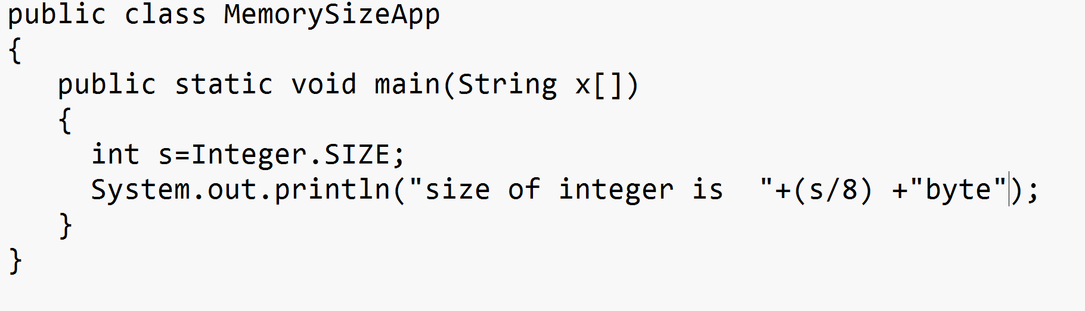

Range of data type or value storing capacity of data type
______________________________________________________________________________
-2147483648 to 2147483647

Q. how this range? Or why this range of integer?
______________________________________________________________________________
Note: if we want to know the calculation of integer data type range, we need to know two things

a. digit counting : digit counting means we can count 0 as value
b. value counting: we cannot count 0

Note: range of data type is dependent on memory size of data type.
format specifier: %d

What is range of integer in c#?
4 bytes

What is range of integer in python?
Range always works with digit counting principle
Format specifier: format specifier means how we can use variable of particular input and output statement.

Integer: %d

long:
how to use in code: long
Memory required: 8 bytes
Range:
63
2 = 8 x 8 = 64 bit
-9223,37,20,36,85,47,75,808 to 92,23,37,20,36,85,47,75,807

Format specifier: %d

short data type
How to use in code: short
Memory required: 2 bytes
Range: -32768 to 32767
15
2
Format specifier: %d

byte:
How to use in code: byte
Memory required: 1 byte
Format specifier: %d
Range: -128 to 127

char data type
______________________________________________________________________________
It is used for store alpha numeric values.
How to use in code: char
Memory required: 2 byte
Range: -32768 to 32767
Format specifier: %c

Float Data type
______________________________________________________________________________
There are two types of float data type

1. float:
How to use in code: float
Memory required: 4 byte
Range: 38 38
-3.14 x 10 to 3.14 x 10
Format specifier: %f

2. double:
How to use in code: double
Memory required: 8byte
Range: 308 308
-1.7 x 10 to 1.7 x 10
Format specifier: %f

boolean data type
______________________________________________________________________________
boolean data type is used for store true or false value

How to use in code: boolean
Memory required: 1 byte
format specifier: %b

Operator
______________________________________________________________________________

Q. what is operator in java?
Operator are the some symbols to perform some operations

Types of operator in java
______________________________________________________________________________
1. Arithmetic operator: it is used for perform arithmetic operations.
Operator | Meaning
+ | Addition
- | Subtraction
* | Multiplication
/ | Division
% | Mod or reminder

2. Assignment operator: Assignment operator is used for assign right hand value into the left hand side variables.
Operator | Meaning
= | Assign

3. Relational operator: Relational operator is used for perform comparison between two values and if comparison get success return true otherwise return false.
Operator | Meaning
< | Less than
> | Greater than
<= | Less than equal
>= | Greater than equal
== | Equal equal
!= | Not equal

4. Logical Operator
______________________________________________________________________________
Q. what is purpose of logical operator?
Combine multiple conditions and mark it as single condition it is major goal of logical operator.

Operator | Meaning
&& | Logical AND –if all conditions are true then condition is true otherwise condition is false.
|| | Logical OR – if any one condition is true then condition is true otherwise condition is false
! | Logical NOT- if true condition then false it and if false condition true
Note: every logical operator works as logical gate internally.

5. Increment and Decrement operator ______________________________________________________________________________
Increment and decrement operator is used for increase the value by one and decrease the value by one.
Operator | Meaning
++ | Increase value by 1
-- | Decrease value by 1
Note: ++ and - - is short cut of +1 and -1
There are two types of increment and decrement operator we have
a. pre increment and pre decrement ______________________________________________________________________________
pre increment means first perform operation and after that shift result value at left hand side
Syntax: op variablename;
Example: int a=10;
++a; //pre increment or --a pre decrement
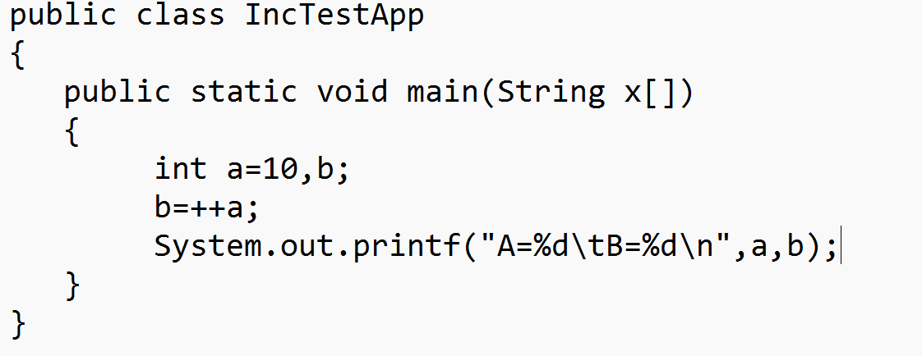
Output
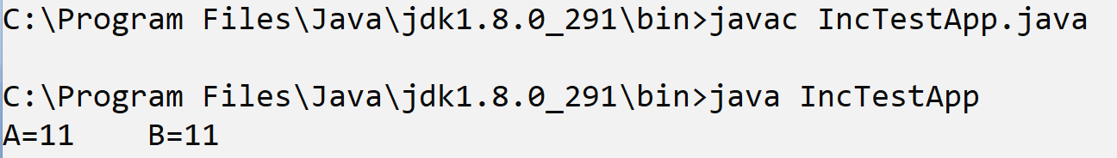

b. Post increment and post decrement: Post increment and post decrement means first shift the value of right-hand side variable in to left hand side and after that perform operation.
Syntax: variablename op;
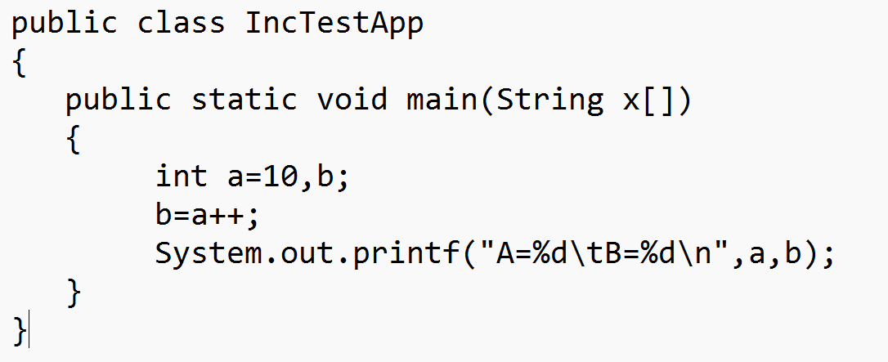
Output
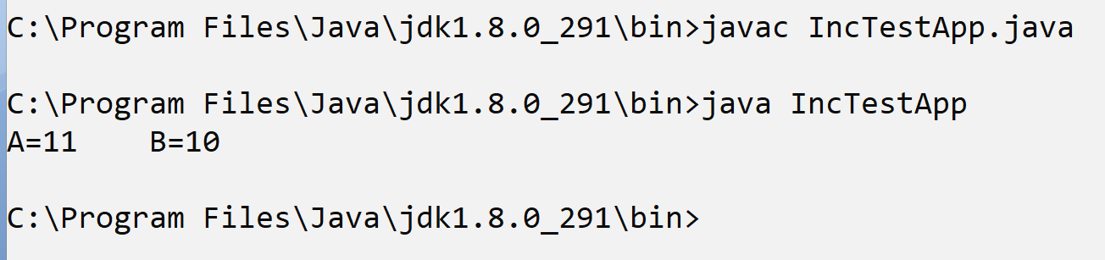

6. Conditional operator
Conditional operator is used for check the conditions
Operator | Meaning
? | Ternary operator
: | Colon operator or options
Generalize syntax of conditional operator

data type variablename = exp1 ? exp2 : exp3;
exp1 is always condition and exp2 and exp3 are the options
If exp1 is true, then exp2 get executed and if exp1 is false then exp3 get executed.

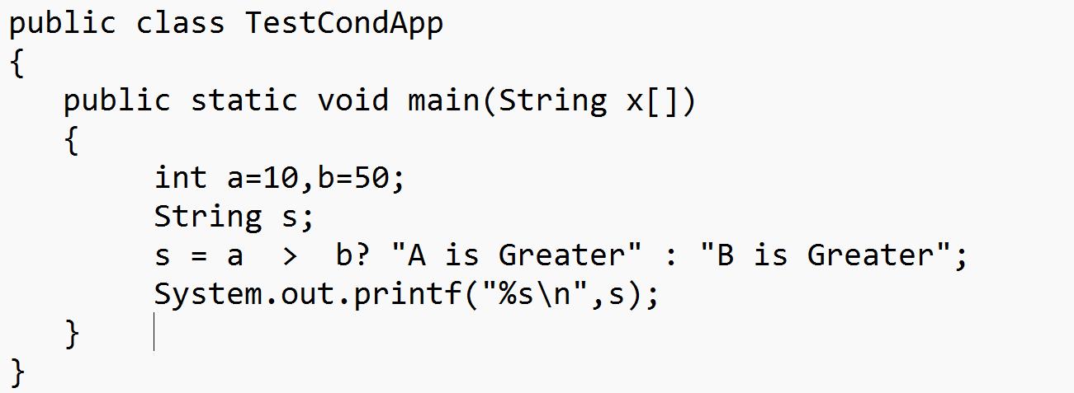
Output
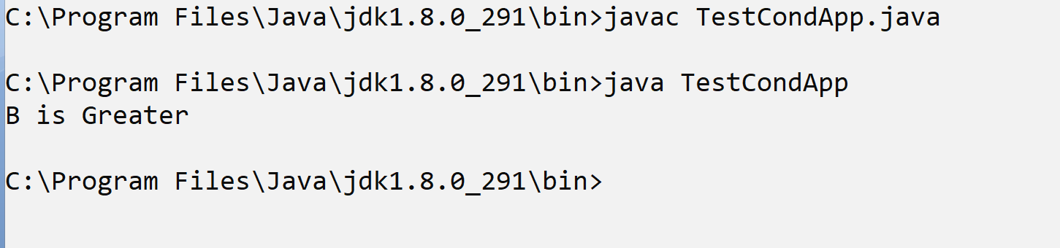

Example: WAP to declare two variables and calculate its addition.
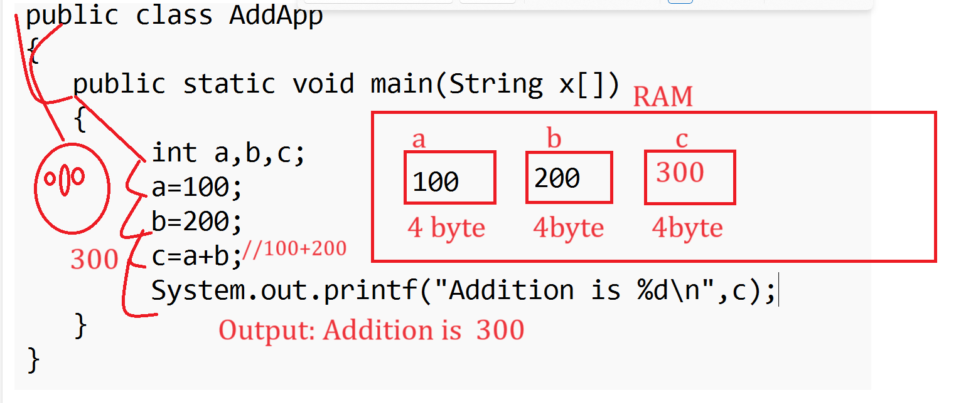
Note: If we think about above code there is limitation we calculate the addition of two fix values. But we want to input two values from keyboard at program run time and after that calculate its addition.

How to accept input at program run time in JAVA
______________________________________________________________________________
If we want to accept the input at run time in java, we have two ways
a) Using Command line argument
b) Using Scanner class

Now we want to accept input using command line argument
Q. What is command line argument?
______________________________________________________________________________
Command line argument is string array parameter present in main function called as command line arguments and it is infinite string array and it is used for accept input at program run time in java means using command line argument we can accept n number of input but the first input of command line is at position of zero.

Example: WAP to accept two values using command line argument at program run time and calculate its addition.
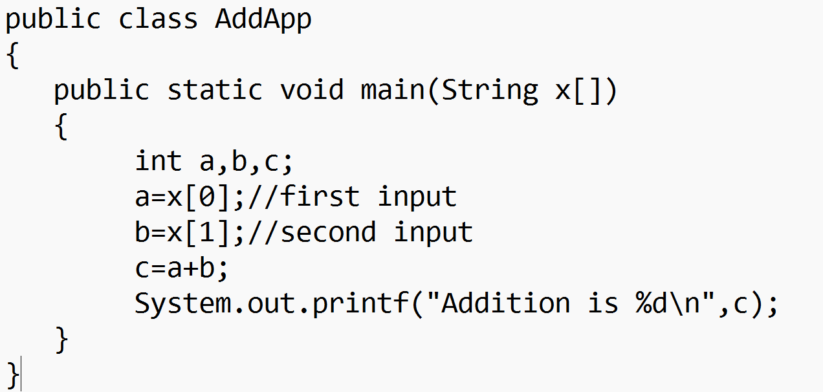
Output
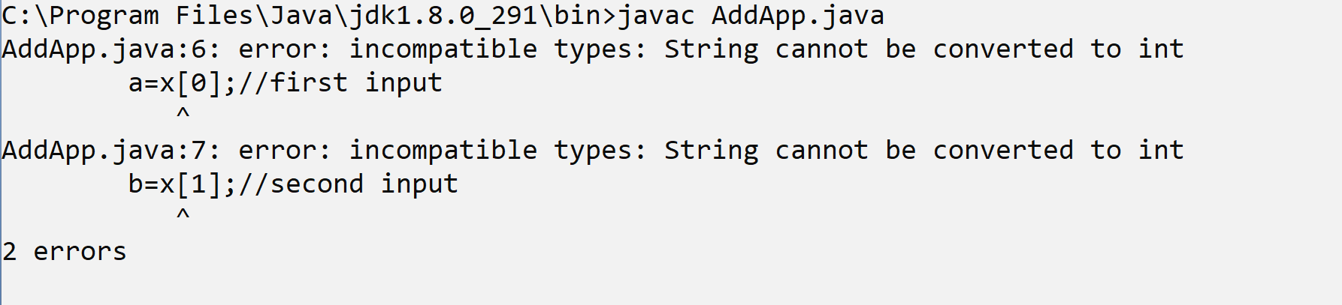
If we think about above code we get compile time error incompatible types string cannot be converted to int

Q.why?
Because we have statement in code a=x[0] and b=x[1] here x[0] and x[1] both are string type data and variable a and b is type of integer and string cannot store directly in integer so compiler will generate compile time error to us.

How to solve this type of error in JAVA?
______________________________________________________________________________
If we want to solve this type of error in java we need to use type casting technique.

Q. What is type casting?
Type casting means if we convert one type of data to another type for single line of code called as type casting.
Means as per our example we required to convert string to integer.

How to convert string to integer in JAVA
______________________________________________________________________________
If we want to convert string to integer in java, we have to use following statement
Syntax: int variablename = Integer.parseInt(String);
Example: int a =Integer.parseInt(x[0]);//here x[0] is string but work as integer with the help of Integer.parseInt() statement
Here Integer is class and parseInt() is static function of Integer class which is used for convert string value to integer value.
Integer - I is capital it is class
DataInputStream – class
Function writing standard in JAVA
If in java function form by using single word, then all letters or alphabet in function must be small
Example: read ();
If function form by using more than one words, then first word all letters must be small and remaining every word first letter should be capital.
readLine();
getEmployeeSalary()
getStudentByUsingItsId() – camel case standard

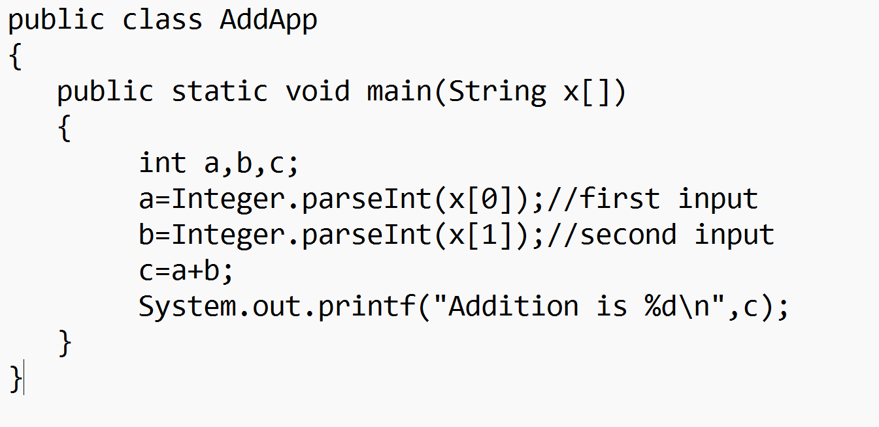
Output
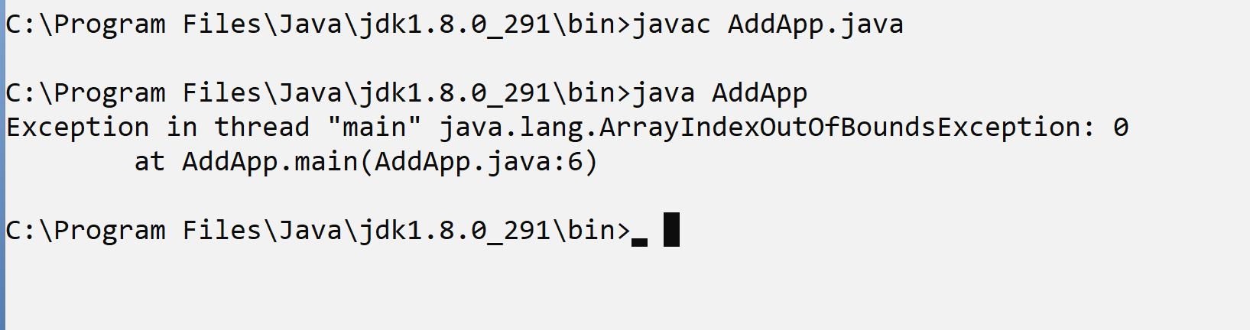
If we think about above screen shot, we get error at program run time
ArrayIndexOutOfBoundsException: 0
Note: if we use command line argument for input then we must be provide input on same line where we run your java program.
If we think about command line argument, then we cannot accept input on new line

So, if we want to accept the input on new line we have one more approach for input known as Scanner class.
Steps to work with Scanner class
______________________________________________________________________________
a) Add java.util package in application
Q. What is package in JAVA?
______________________________________________________________________________
package is a collection of classes and interfaces in java same like as header file in c language but header file is collection of function means we can say package is library in java.
If we want to add package in code, we have to use import keyword.
Syntax: import packagename.*; : this syntax indicate it is wild card import here * denote the wild card import means we can import all member from package in application
or
import packagename.classname; it is called as single type import and using this technique we can use or we can import specific member from package in application.
Syntax: import packagename.classname;
Example: import java.util.*;
or
import java.util.Scanner;
b) Create object of Scanner class
______________________________________________________________________________
Syntax: Scanner ref = new Scanner (System.in);
Example: Scanner xyz = new Scanner (System.in);
c) Use its method to work with Scanner.
______________________________________________________________________________
int nextInt(): this is used for accept the input of type integer
float nextFloat(): this is used for accept input of type of float
double nextDouble(): this is used for accept input of type double.
long nextLong(): this is used for accept input of type long.
short nextShort(): this is used for accept input of type short.
String nextLine(): this is used for accept input of type string.
etc
You can use all methods by using Scanner object.
scannerref.methodname()

Example: WAP to input two values from keyboard and calculate its addition.
Example with source code
import java.util.*;//step1
public class ScanAddApp
{
public static void main(String x[])
{
Scanner xyz =new Scanner(System.in);//step2
int a,b,c;
System.out.println("Enter first value");
a=xyz.nextInt();//step3
System.out.println("Enter second value");
b=xyz.nextInt();
c=a+b;
System.out.printf("Addition is %d\n",c);
}
}
Example: WAP input two values from keyboard and perform swapping on it
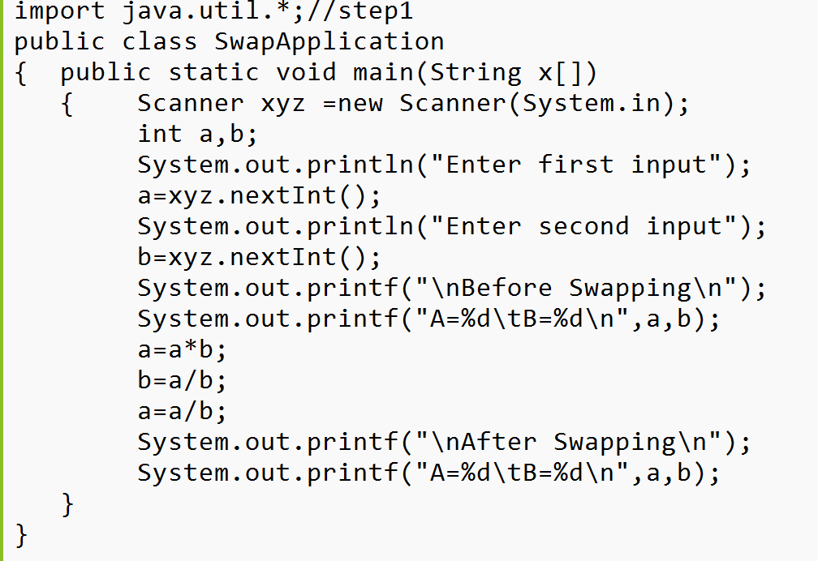

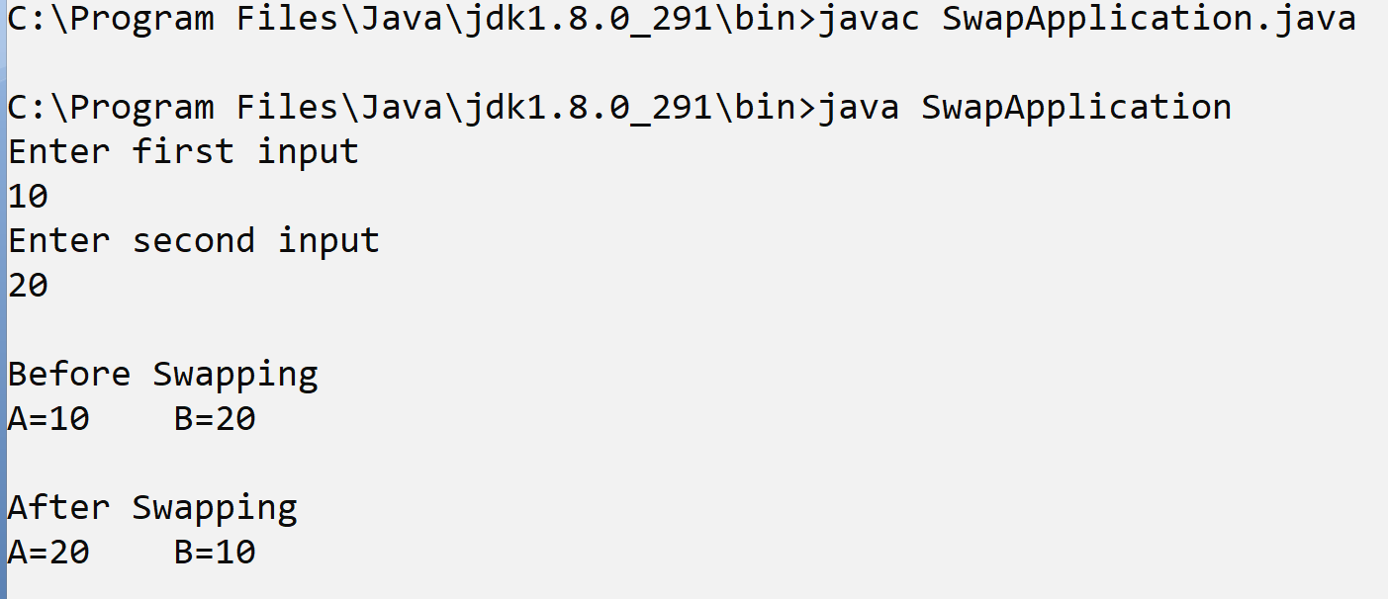

Example with source code
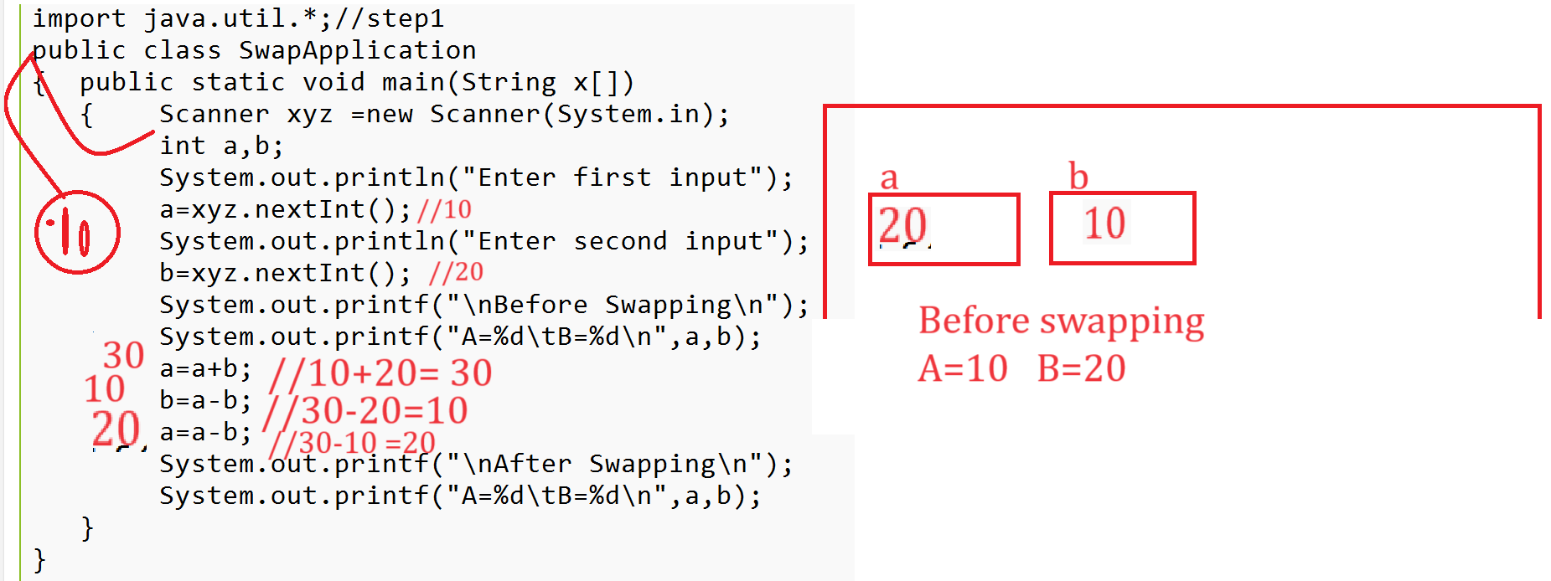
or
Example: WAP to input three-digit number and reverse it.
import java.util.*;
public class RevNumApp
{ public static void main(String x[])
{ Scanner xyz = new Scanner(System.in);
int no,rev=0,rem;
System.out.println("Enter number");
no=xyz.nextInt();
rem=no%10;
no = no/10;
rev=rev+rem*100;

rem=no%10;
no = no/10;
rev=rev+rem*10;

rem=no%10;
no = no/10;
rev=rev+rem*1;
System.out.printf("Reverse number %d\n",rev);
}
}
or
import java.util.*;
public class RevNumApp
{ public static void main(String x[])
{ Scanner xyz = new Scanner(System.in);
int no;
System.out.println("enter three digit number");
no=xyz.nextInt();
System.out.printf("Before reverse is %d\n",no);
no= (no%10)*100 +((no/10)%10)*10 +no/100;
System.out.printf("After reverse is %d\n",no);
}
}

Example: WAP to swap first and last digit of number
import java.util.*;//step1
public class SwapFirstLastDigitApp
{ public static void main(String x[])
{ Scanner xyz = new Scanner(System.in);//step2
System.out.println("Enter five-digit number");
int no=xyz.nextInt();
System.out.printf("Before swapping %d\n",no);
int last=no%10;//extract last digit
no=no/10;//remove last digit
int first=no/1000;//extract first digit
no=no%1000;//delete first digit
last=last*10000;//shift position of digit from0 to 1000
no=no*10;
no=last+no+first;//perform addition for shift digit
System.out.printf("After swapping %d\n",no);
}
}
Example:
WAP to input selling price and cost price of item and check seller made profit or loss using conditional operator.
Algorithm: Write steps for solve any problem called as algorithm.
import java.util.*;
public class CheckProfitLossApp
{
public static void main(String x[])
{ Scanner xyz = new Scanner(System.in);
int sp,cp;
String result;
System.out.println("enter selling price and cost price");
sp=xyz.nextInt();
cp=xyz.nextInt();
result=sp>cp?"Profit":"Loss";
System.out.printf("Result is %s\n",result);
}
}

Example: WAP to input number and check number is even or odd using conditional operator.
import java.util.*;
public class EvenOddApp
{
public static void main(String x[])
{ Scanner xyz = new Scanner(System.in);
int no;
String result;
System.out.println("enter selling price and cost price");
no=xyz.nextInt();
result=no%2==0?"Even":"Odd";
System.out.printf("Result is %s\n",result);
}
}

7. Bitwise operator
______________________________________________________________________________
If we want to work with bitwise operator, we should have to know following things
1. Number system
2. Conversion between decimal to binary or binary to decimal
3. Binary AND, OR etc. operation
4. One’s complement
5. Two’s complement

Number System:
Q. What is number system?
______________________________________________________________________________
Number system means to decide how user values represent in computer system or how numbers or values represent by computer called as number system.

There are four types of number system
______________________________________________________________________________
1. Decimal: decimal number means value between 0 to 9 and the base of decimal number system is 10.

Q. What is base?
______________________________________________________________________________
Base indicate the number of digit present in number system called as base.
Q. Why use base?
______________________________________________________________________________
Base is used for identify number in number system
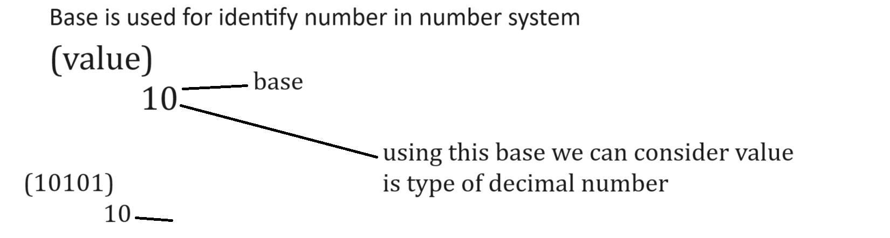
2. Binary: binary number system means it contain only two digits 0 and 1 so the base of binary is 2
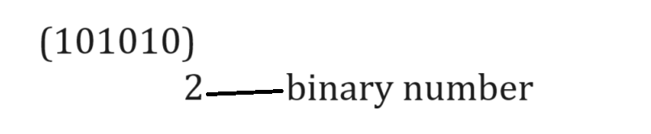
3. Octal: octal number system means it contain 0 to 7 values, so the base of octal number system is 8
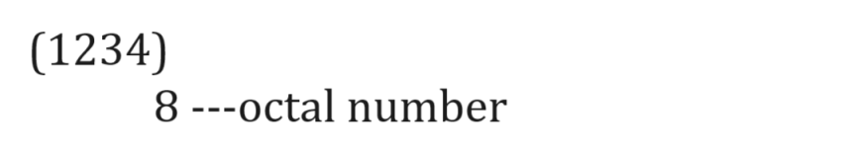
4. Hexa Decimal: hexa decimal number system means it contain value between 0 to 15 and from 10 consider A to F means 10-A ,11-B,12-C,13-d,14-e,15-f so it contains total number of digit 16 so the base of hexa decimal is 16
Example: (AB45) -- (101145)
16

Conversion between number system
______________________________________________________________________________
1. Decimal to binary conversion
2. Binary to decimal conversion

How to convert decimal number into binary
______________________________________________________________________________
If we want to convert any decimal number into binary number, then we need to divide decimal number by 2 and calculate its reminder and catch all reminders from bottom to top
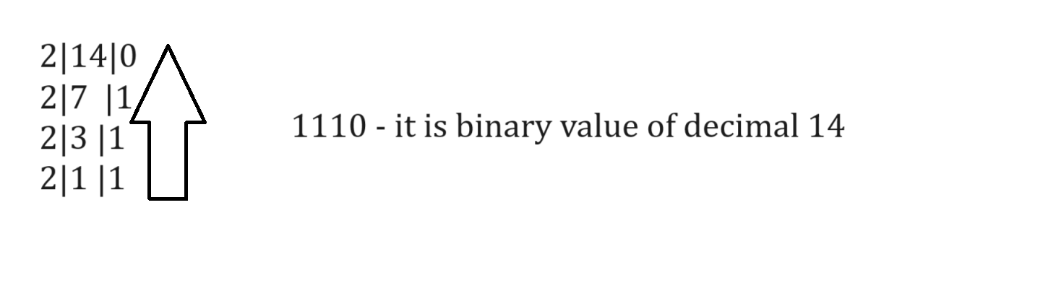
Example: find the binary value of 12
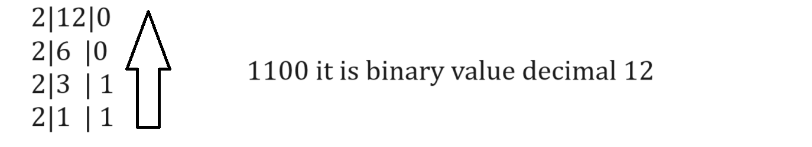

How to convert binary value to decimal value
______________________________________________________________________________
If we want to convert the binary value to decimal value, we required to multiply every binary digit from value by 2 and arrange its index from right hand side start with 0 to n-1
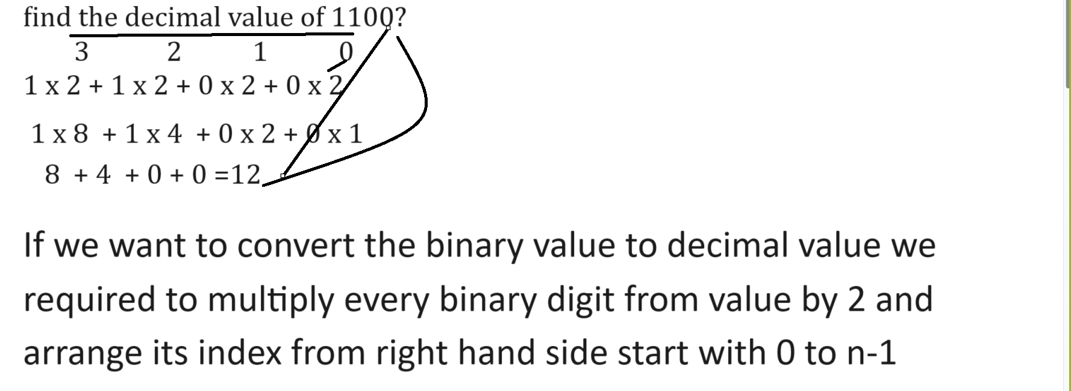
Example: find the decimal value of 0111?
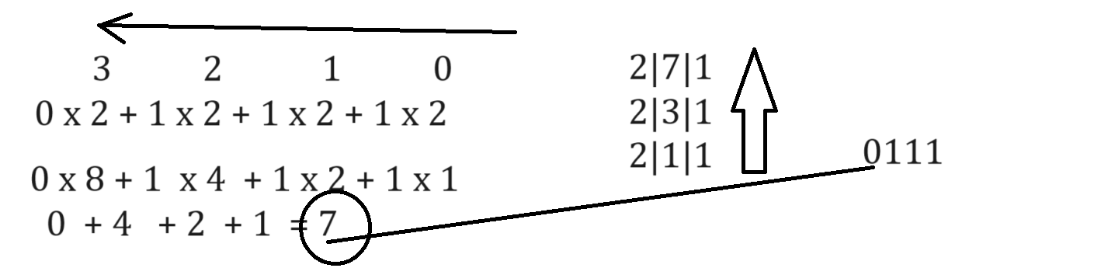

Binary AND, OR, XOR Operations
______________________________________________________________________________
AND Operation: if both values are 1 then result is 1 means if first input value is 1 and second input value is 1 then output is 1 if first input value is 0 then second value is not consider or check result is 0
If first value is 1 and second is 0 then result is 0
And if first 0 and second is 0 then result is 0
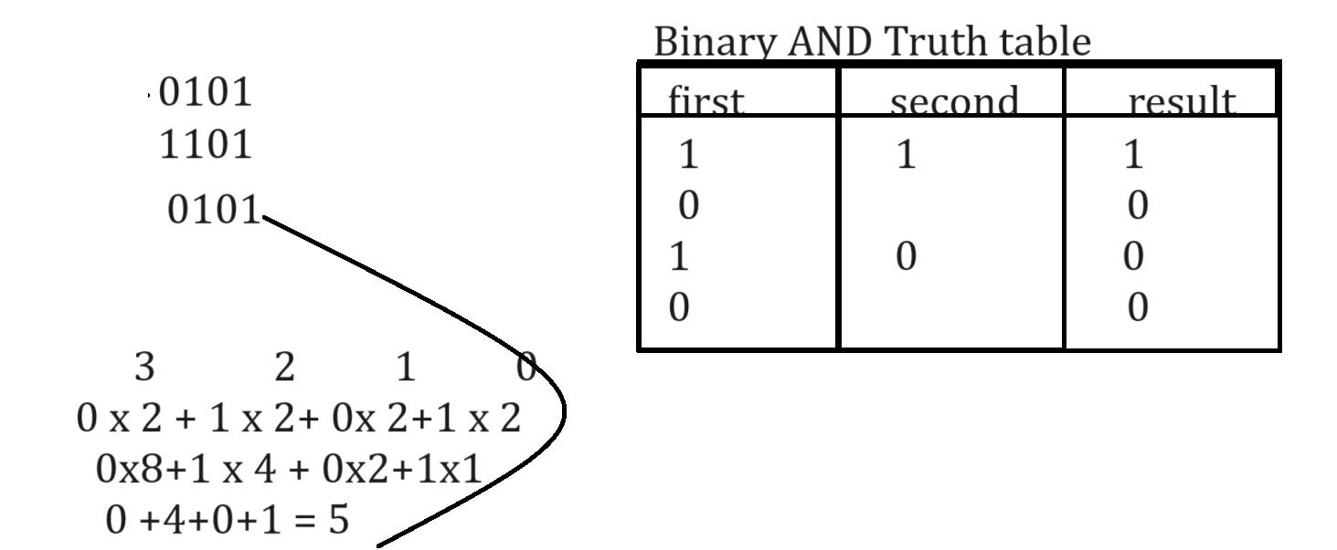
Binary OR operations
______________________________________________________________________________
Binary OR operation means if first input is 1 and second is 0 then result is 1 if first input is 0 and second is 1 then result is 1 if first input is 1 and second input is 1 then result is 1 and if first is 0 and second is 0 then result is 0
Note: if your first input is 1 in OR operation then second never check internally by default output is 1
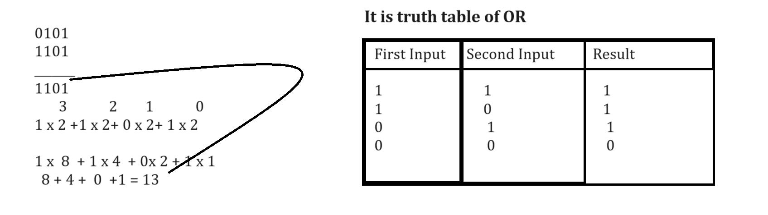
Binary XOR operation
if we think about binary XOR operation then if we have same input means if your first input is 1 and second input is 1 then result is 0 and if your first is 0 and second input is 0 then result is also 0 and if your first is 1 and second is 0 then output is 1 and if first is 0 and second is 1 then output is 1.
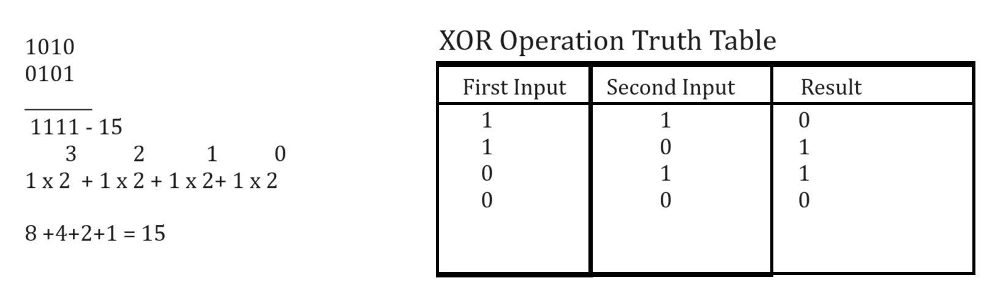

One’s complement
______________________________________________________________________________
One’s complement means convert 0 to 1 and 1 to 0 called as one’s complement and when we convert in decimal then use -(minus) symbol at left hand side
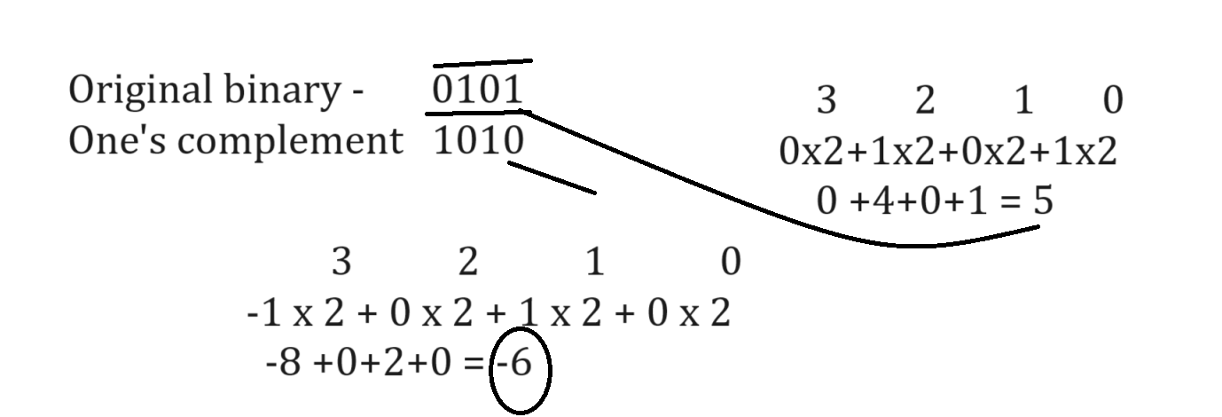

Bitwise operator

Operator | Meaning
| | Bitwise or operator
& | Bitwise AND operator
<< | Left shift operator
>> | Right shift operator
~ | One’s complement
^ | XOR operator

Bitwise OR (|): this operator internally performs bitwise OR operation means accept the decimal number by code and convert in binary and perform binary OR operation on it and again convert in decimal and give result to us.

Example with source code
public class ORAPP
{
public static void main(String x[])
{
int a=5,b=2,c;
c=a|b;
System.out.printf("C = %d\n",c);
}
}

Bitwise AND Operator (&):
______________________________________________________________________________
bitwise & operator is used for perform binary & operation on decimal number means accept decimal number from code and convert in binary number internally and perform binary and operation on it and generate result in binary form and convert binary result in decimal form

Example with source code
public class ANDAPP
{ public static void main(String x[])
{ int a=5,b=2,c;
c=a&b;
System.out.printf("C = %d\n",c);
}
}
Output
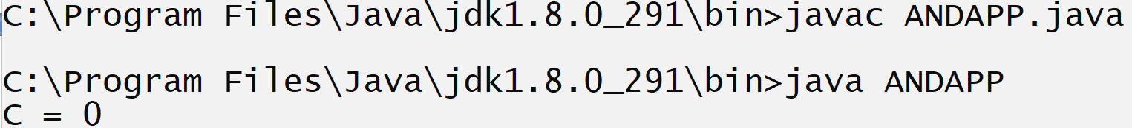

Left shift operator (<<)
______________________________________________________________________________
left shift operator accept the decimal number or integer number from code and convert represent in memory as binary digit with bits of size and shift bit from right hand side to left hand side and add 0’s adds right hand side and again convert binary after shifting into decimal and give result to us.
Example with source code
public class LeftShiftApp
{ public static void main(String x[])
{ int a=5,b;
b=a<<2;
System.out.printf("B = %d \n",b);
}
}
Right shift operator ( >> ) :right shift operator shift bit from left hand side to right hand side and remove extra bit from right hand side and add 0’s at left hand side.

Example with source code
public class RightShiftApp
{ public static void main(String x[])
{ int a=5,b;
b=a>>2;
System.out.printf("B = %d \n",b);
}
}

XOR (bitwise operator)
______________________________________________________________________________
XOR operator is used for convert your decimal value in to binary value and perform XOR operation on it and generate result in binary format and again convert your binary result in to decimal number and give us

Example with source code
public class XORApp
{ public static void main(String x[])
{ int a=5,b=4,c;
c=a^b;
System.out.printf("C = %d \n",c);
}
}

Example: WAP to swap digit by using XOR operator.
import java.util.*;//step1
public class SwapApp
{ public static void main(String x[])
{ Scanner xyz = new Scanner(System.in);
int a,b;
System.out.println("Enter two values");
a=xyz.nextInt();
b=xyz.nextInt();
System.out.printf("\nBefore Swapping \n");
System.out.printf("A=%d\tB=%d\n",a,b);
a=a^b;
b=a^b;
a=a^b;
System.out.printf("\nAfter Swapping \n");
System.out.printf("A=%d\tB=%d\n",a,b);
}
}

One’s complement: (~)
______________________________________________________________________________
one’s complement operator accepts decimal number from code and convert decimal number into binary number and apply one’s complement rule on it and again generate the result in binary format and convert that result from binary to decimal but at the time of conversion use minus symbol with left hand side bit and convert in decimal and give result to us

Example with source code
public class OnesCompApp
{ public static void main(String x[])
{
int a=5,b;
b=~a;
System.out.printf("B = %d\n",b);
}
}
Output
